Mall Navigation and Online Ordering System

Submitted in Partial Fulfillment of the Recruitment for the Degree of

Bachelor of Technology

In

Computer Science & Engineering

2021

Submitted to

JAYPEE INSTITUTE OF INFORMATION TECHNOLOGY

NOIDA (U.P)



Submitted by

ARSH THAKUR (19103132)  
AAYUSH MITTAL (19103141)

CHINMAYA PARAKH (19103140)

Under the guidance of

BHAWNA SAXENA

DEPARTMENT OF COMPUTER SCIENCE

JAYPEE INSTITUTE OF INFORMATION TECHNOLOGY

YEAR – 2021

**Problem Statement**  
Make a program for a shopping complex which customers can use to navigate through the shopping complex and to order items online once they are logged in the system. Create as many shops as you want for exploring and to order online.  
  
**Introduction**  
Customers sign up and log in to the program and use it to order items online and to navigate through the shopping complex to find the shops they're looking for.

**Description**

To start shopping or navigating, the customer has to sign in/sign up. After signing in, the customer is given the choice to explore or order the products online.

If the customer chooses to explore, they would be given the location of their required shops.

If the customer chooses to order, they would be provided with the menu of their required goods.

They can then choose their required products from the menu and their bill will be displayed accordingly.

For protection of the customers accounts, hashing is used to store the passwords.

**List of Data Structures used**  
Linked lists

Array of structures

Vectors

Hashing

File Handling

**OOPs Concepts used**  
Classes and objects

Encapsulation

Inheritance

Polymorphism

Function Overloading

**Tools used**

GCC compiler

**Detailed design of the project**  
We used structures and classes for the basic design of the model. Structs for food, shoes, clothes were made whose objects were made in their corresponding classes. These classes were then later inherited to make complete shops.

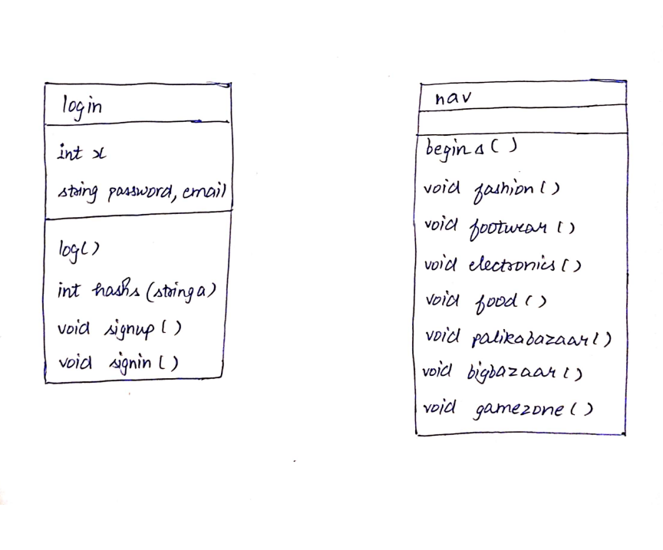

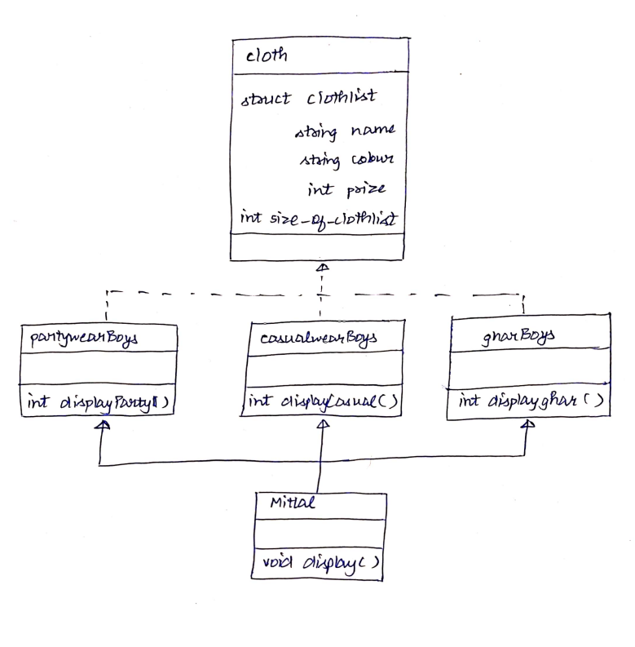

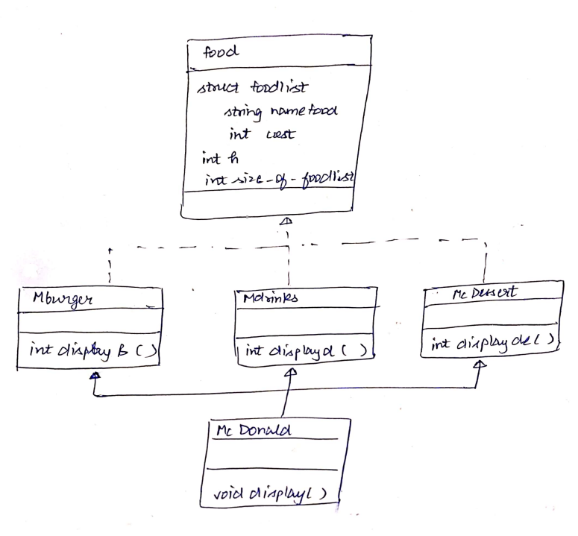

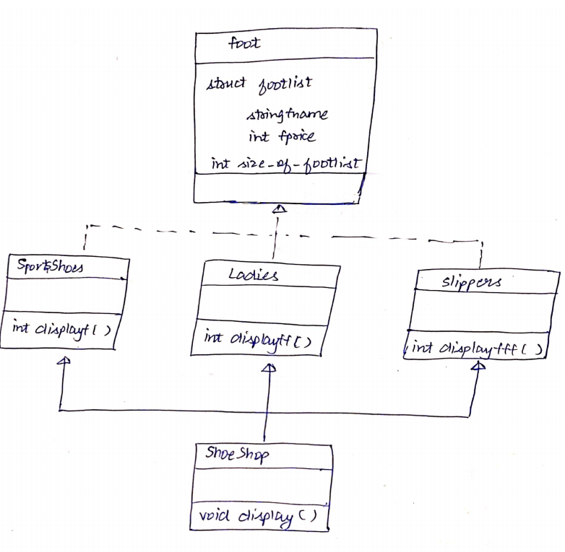

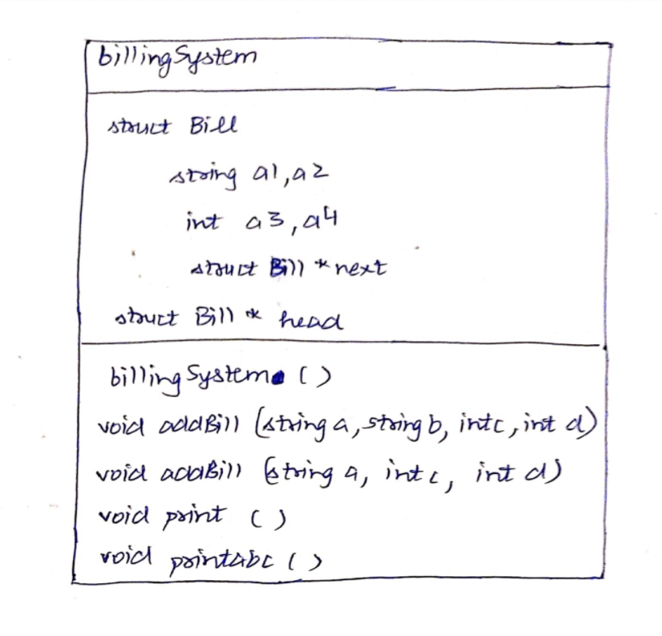

**Implementation**

**LOGIN**

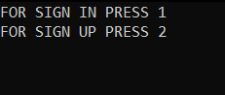

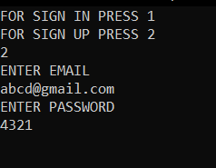

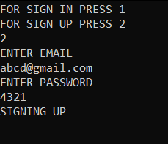 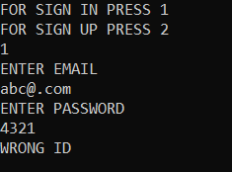 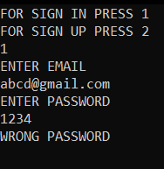

**EXPLORE**

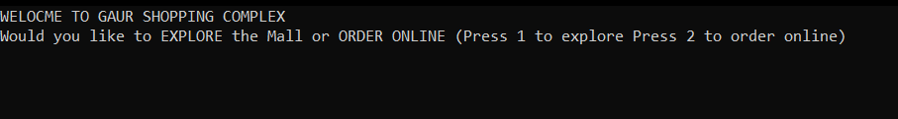

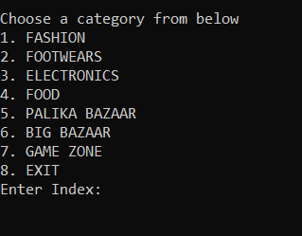

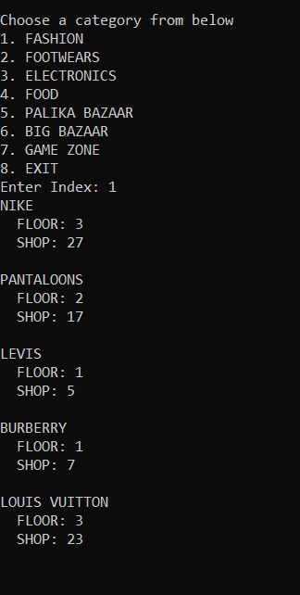

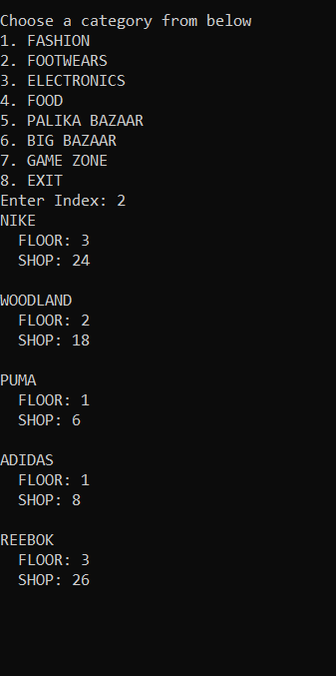

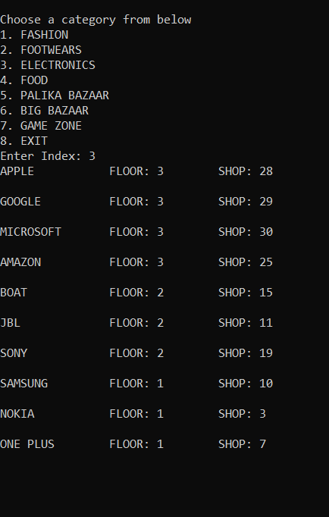

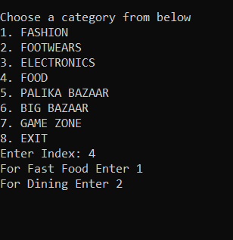

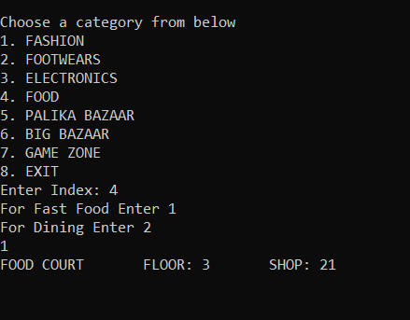

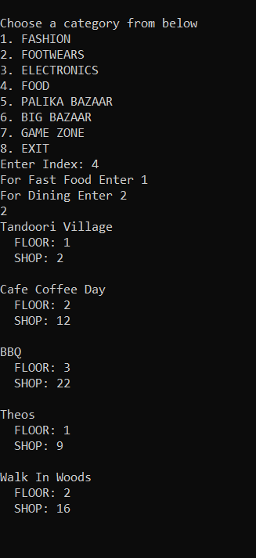

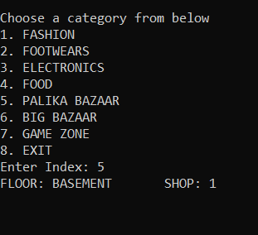

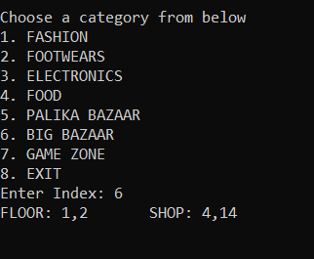

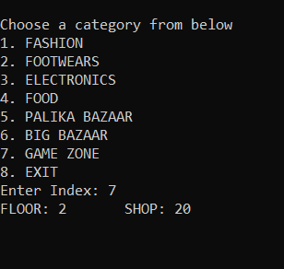

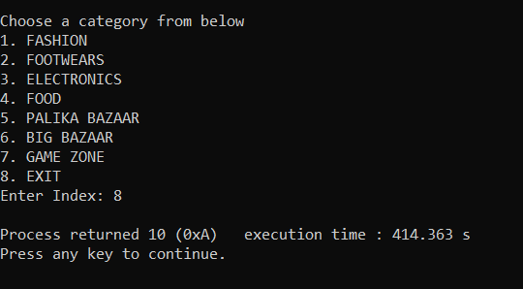

**ORDER ONLINE**

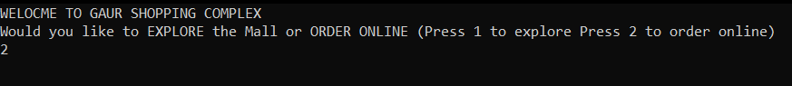

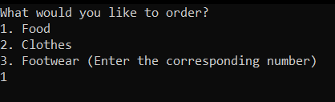

Ordering Food

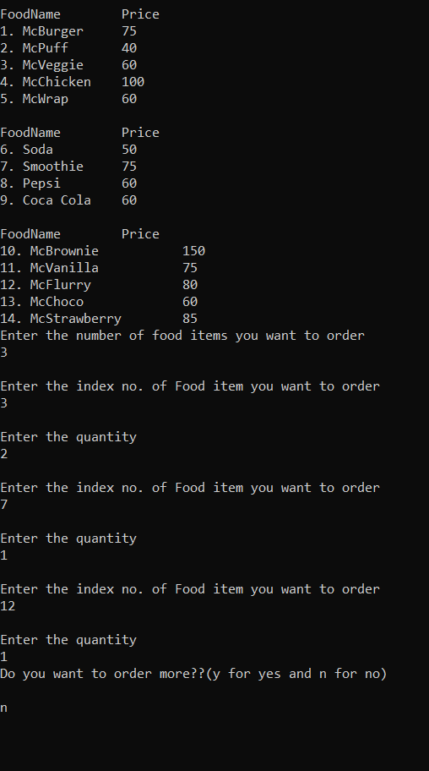

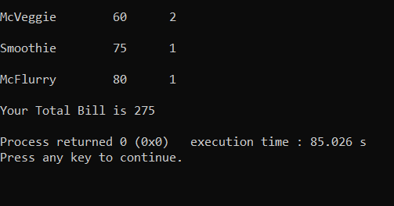

Ordering Clothes

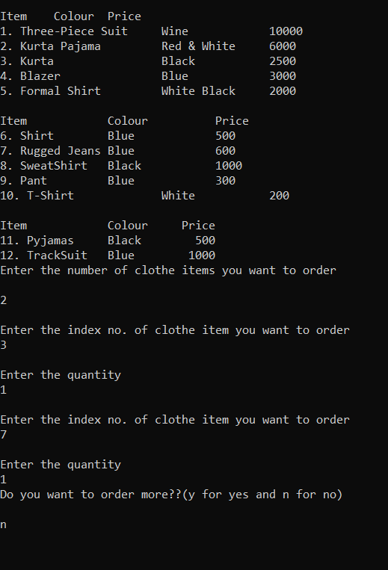

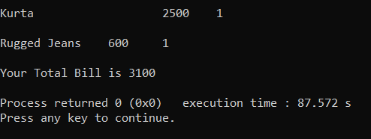

Ordering Footwear

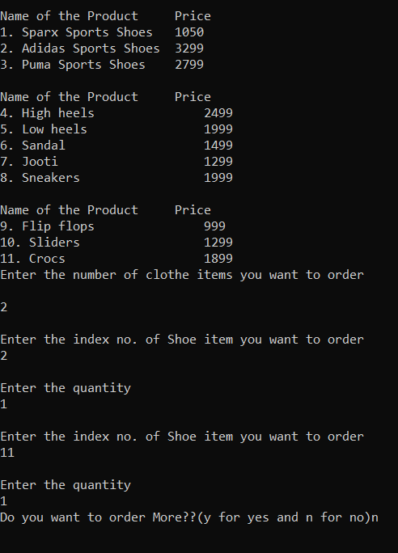

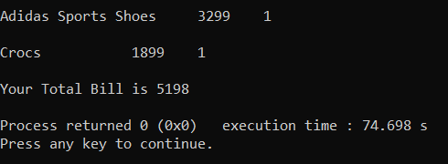

**Conclusion**

We all know that our lives are now going digital. In this pandemic we realized how important digitization is to us so our program gives us freedom to order our favorite products from our favorite shops by sitting at home. Moreover we have all experienced situations where we get lost while finding certain shops in malls so our program also helps finding shops in the mall with different criteria.

**References**

[Data Structures - GeeksforGeeks](https://www.geeksforgeeks.org/data-structures/)

[Data Structures | DS Tutorial - javatpoint](https://www.javatpoint.com/data-structure-tutorial)

[OOPs Concepts - Javatpoint](https://www.javatpoint.com/java-oops-concepts)

[Object Oriented Programming in C++ - GeeksforGeeks](https://www.geeksforgeeks.org/object-oriented-programming-in-cpp/)

[Hashing Data Structure - GeeksforGeeks](https://www.geeksforgeeks.org/hashing-data-structure/)